How SDLC is governed in TFS

Click here to enter text.
Information Services
October 30, 2020

Contents
Introduction 3
SDLC 3
Plan 4
Code 5
Review 5
Test 5
Release 6
Support 6
Annex A - Product Backlog Item (PBI) States by SDLC Stage 7
Annex B - Request Code Review in Visual Studio 8
Annex C - Developer Work Board in TFS 9

Introduction

Team Foundation Server provides a set of collaborative software development tools that integrates with your existing IDE or editor; thus enabling your cross functional teams to work effectively on software projects of all sizes.

A product backlog item ("PBI", "backlog item", or "item") is a unit of work small enough to be completed by a team in a two-week period. Backlog items are decomposed into one or more tasks. The "Product backlog Item" is indeed the what, the functionality that needs to be built. The Task describes the steps that need to be taken to get there.
*** Note most of this document is accurate, but dated. Working with BAS team to come up with a mutual standard as Digital needs to also align with IS QA and digital QA ****

SDLC

Plan

TFS supports multiple products and additional areas under each product. Currently, ADS has access to the following projects LiveCycle, FileNet, Websites, WAVE, INFOserver, Sitecore and ADS Applications. Product Backlog Items (PBI) are created during the SDLC Plan Stage, and PBIs under development always have a New State. PBIs must be approved by the ADS manager before advancing to the SDLC Code Stage. To be considered for approval PBIs must contain title, PBI Type, Reason, Description, attached Business Requirements Document (BRD) and attached Architecture Document. Product Backlog Items (PBI) will be decomposed into one or more tasks during the coding stage.

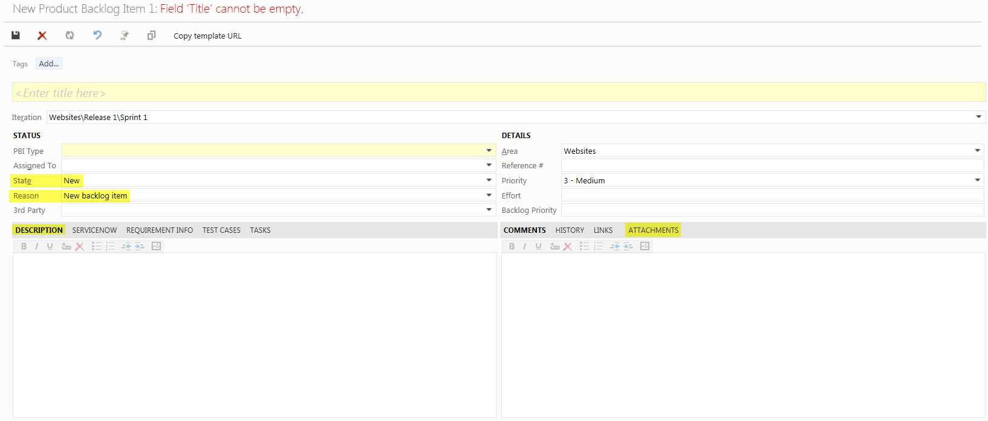

Code

During the SDLC Coding Stage, the actual development begins and the deliverable is developed. Developers must follow the coding standards agreed to by ADS. Code is developed to implement functionality detailed by the BRD. The programming languages used are listed in the Architecture document.

ADS developers must backup their work using a Shelve Pending Changes operation at the end of each day.
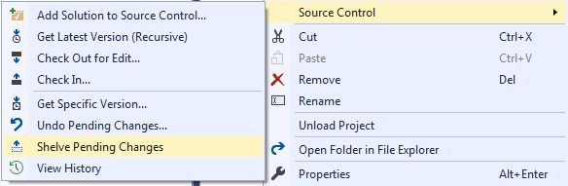

ADS developers will create a TFS IM Release PBI and deploy the deliverable to the QA server documenting each step.
ADS developers must Check-In their code after all code is reviewed and accepted. The PBI number and a meaningful comment will be included with the Check-In.
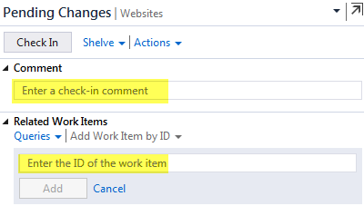

Review

All code produced in the SDLC Coding Stage must be peer reviewed before CWB’s QA team is engaged. Peer reviews are used for sharing knowledge, cleaning up loose ends, consolidating TODOs, and to ensure consistency, legibility, prevent accidental errors and coding standards compliance.

Test

The SDLC Test Stage refers to the testing only stage of the deliverable. The PBI will be assigned to a member of the QA team. Defects are reported, tracked, fixed and retested, until the deliverable meets the functionality defined in the BRD. This is handled by QA who will assign the PBI back to ADS with comments.

Release

During the SDLC Release Stage, the release team lead will follow the TFS IM Release PBI. The Release PBI details the tested steps required to promote the deliverable into production. After the release is completed, the State of both PBIs will be set to Done.

Support

CWB users must create a ServiceNow Incident if they discover a defect with any internally developed software. A TFS Bug will then be generated and the ServiceNow number will be saved with the TFS Bug. The ADS Manager will approve bugs before coding, review and testing will begin.

Annex A - Product Backlog Item (PBI) States by SDLC Stage

SDLC Stages |  | Start State |  |  | End State
 |  | PBI State | Person Role |  | PBI State | Person Role
Plan |  | New | PBI Author |  | Approved | ADS Manager
Coding |  | Approved |  |  | In Progress | ADS Lead
Review
Testing |  | In Progress |  |  | Ready For Release | QA Lead
Release |  | Ready For Release |  |  | Done | Release Lead

Table A1: Lists the SDLC stages, TFS PBI State at the start and end of each SDLC stage, and the role of the person assigned to updating TFS. TFS will maintain audit information under the history tab.

Annex B - Request Code Review in Visual Studio

- Open Team Explorer Within Visual Studio

- Click on My Work

- Enter the code reviewers name, enter and subject and click on Submit Request

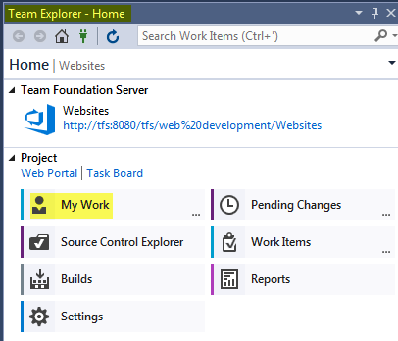

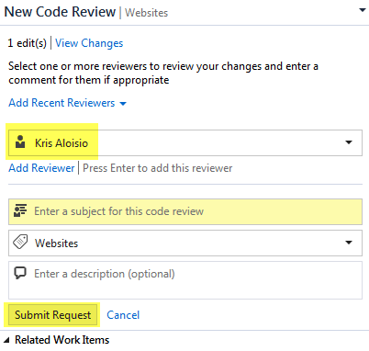

Annex C - Developer Work Board in TFS

